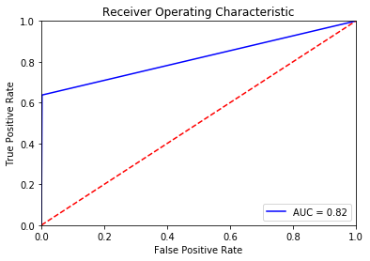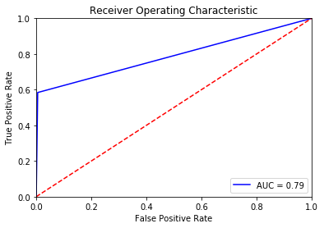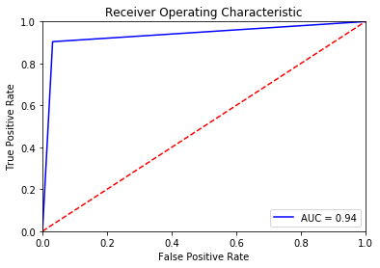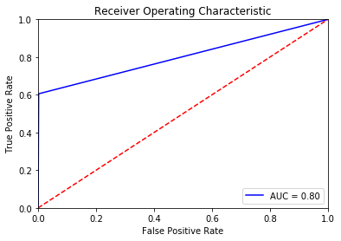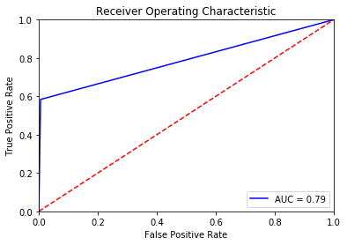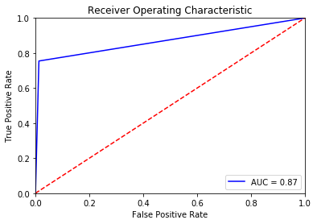

**Figure 8 – Random Forest**

**Figure 7 - CART**

**Figure 5 - KNN**

**Figure 6 – Naïve Bayes**

**Figure 4 – Random Forest**

**Figure 3 - CART**

**Figure 2 – Naïve Bayes**

**Figure 1 - KNN**